Country Focus Report: Instructions for Expert Panel Members

- SCOPE OF ANALYSIS

Our Understanding of the Enabling Environment

An enabling environment is one where civil society can thrive, express itself freely, and actively engage in shaping its context. Freedom of expression is indispensable in an enabling environment; citizens must feel secure in expressing opinions and sharing information online and offline. Similarly, the freedoms of association and peaceful assembly allow individuals to pursue collective goals unhindered. Protecting human rights defenders and protesters is essential for creating an environment conducive to civil society's activities. When these rights are respected and protected we have an open civic space and citizens have space to organise, participate, and communicate effectively.

While "civic space" and "enabling environment" are often used interchangeably, the "enabling environment" is a broader concept more action-oriented and outcome-driven. It describes an environment that not only respects and protects fundamental freedoms but also facilitates the effective work of civil society.

Beyond safeguarding the right to associate, the autonomy and operational freedom of civil society must be ensured. This assurance needs a legal and regulatory framework that facilitates their establishment, protects against unwarranted interference, and provides a solid legal basis for their activities. Additionally, access to sustainable resources is critical for enabling civil society to carry out its mission effectively.

Furthermore, a constructive engagement between the state and civil society plays a pivotal role in fostering an enabling environment, as both types of actors (public bodies and civil society actors) converge in the formulation, implementation and evaluation of public policies. This engagement should thus be characterised by transparency, accountability and meaningful, inclusive collaboration in policy-making and governance processes. Acknowledging civil society's contributions cultivates public support and inclusivity toward their initiatives and accomplishments, thereby strengthening their environment and eventually triggering a virtuous circle of mutual trust and recognition.

Finally, civil society actors should have access to digital technologies and be able to operate freely and securely in the digital space, without the threat of censorship, online manipulation, disinformation, or disruption of digital rights.

As a complex and multifaceted concept that can only be defined in relative terms, we have broken down the enabling environment for civil society into six key enabling principles for methodological reasons (presented in the illustration below):

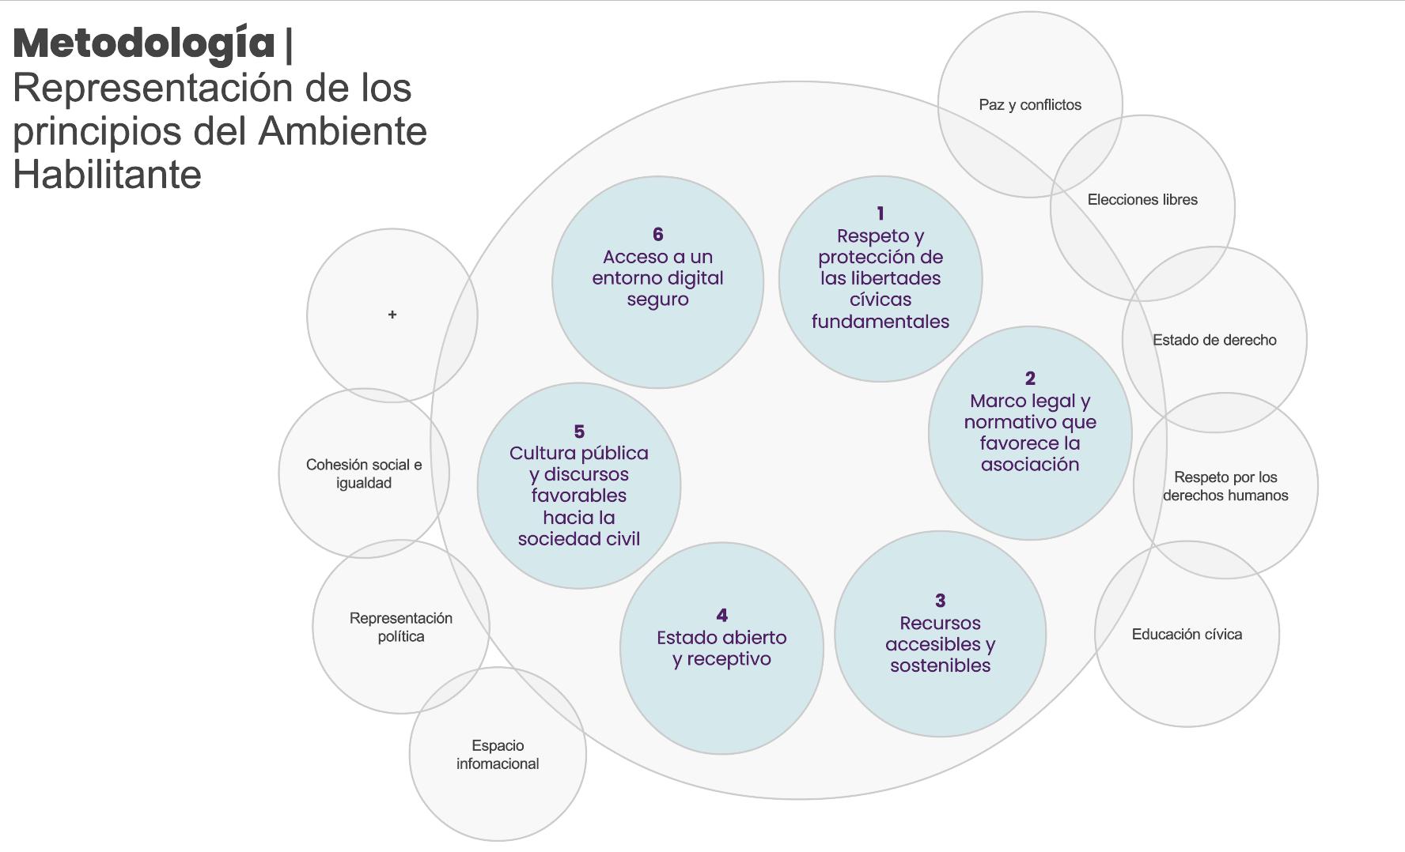

It’s important to acknowledge that while the six principles listed above provide a foundation, the enabling environment for civil society is influenced by additional factors not explicitly mentioned. These factors encompass essential components of a functioning democratic system, such as the rule of law, free and fair elections, political representation, and an open information space. Furthermore, external elements like conflicts, inequality and social cohesion (or lack thereof) can also significantly impact this environment. However, when evaluating the enabling environment in its country focus reports, EU SEE exclusively relies on its defined six principles, which are designed to offer a clear and measurable assessment of the conditions in which civil society evolves.

Definition of Enabling Environment for Civil Society:

The combination of laws, rules and social attitudes that support and promote the work of civil society. Within such an environment, civil society can engage in political and public life without fear of reprisals, openly express its views, and actively participate in shaping its context. This includes a supportive legal and regulatory framework for civil society, ensuring access to information and resources that are sustainable and flexible to pursue their goals unhindered, in safe physical and digital spaces. In an enabling environment, the state demonstrates openness and responsiveness in governance, promoting transparency, accountability, and inclusive decision-making. Positive values, norms, attitudes, and practices towards civil society from state and non-state actors further underscore the supportive environment.

Our Understanding of Civil Society

CIVICUS has long used a working definition of civil society as being "the arena, outside of the family, the state, and the market, which is created by individual and collective actions, organisations and institutions to advance shared interests”. The EU SEE project aims to improve the capacity and ability of civil society to detect and respond to situations of a deteriorating or improving enabling environment, so, in the context of our system, it is crucial to delineate precisely which actors fall under civil society. These encompass a diverse range of organization, associations and groups (see detailed list below).

We acknowledge that to study the enabling environment in which these entities work, we need to evaluate the actions of additional stakeholders such as, the government, the media, politicians, and businesses. While these stakeholders are integral to shaping the environment, they are not the primary actors in our system.

Within the EU SEE framework, civil society actors encompass:
- Trade unions
- Women’s organisations
- Student or youth organisations
- Developmental CSOs (e.g. NGOs working on literacy, health, and social services)
- Foundations
- Advocacy CSOs (e.g. civic action, social justice, human rights, consumers’ groups)
- CSOs active in research, information dissemination, education, and training (e.g. think tanks, resource centres, non-profit schools)
- Non-profit media groups
- Associations of socio-economically marginalised groups (e.g. poor people, homeless, landless, immigrants, refugees)
- Social service and health associations (e.g. charities raising funds for health research and services, mental health associations, associations of people with physical disabilities)
- Other fundraising bodies and organisations
- Professional and business organisations (e.g. chambers of commerce, professional associations)
- Community organisations (e.g. village associations, neighborhood committees)
- Community-level groups or associations (e.g. burial societies, self-help groups, parents’ associations, village associations, Indigenous people’s associations, Waqfs, monasteries, and mosque-based associations)
- Economic interest CSOs (e.g. cooperatives, credit unions, mutual saving associations)
- Ethnic, traditional, or Indigenous associations or organisations
- Environmental CSOs
- Faith-based organisations
- Culture and arts and social and recreational CSOs
- CSO networks, federations, support organisations
- Social movements
- Social business (not oriented to profit)

This list was created collectively with a group of civil society representatives for a previous project implemented by CIVICUS and ICNL and adapted by the EU SEE consortium and network members.

- PROCESS

Use the following steps to guide you through the individual scoring process. This same process will be repeated during the expert panel discussion meeting, where panel members will discuss their initial scores, evidence for these scores, and determine by consensus the final scores for each of the dimensions.

Step 1: Please start by reviewing last year’s report and examining the information shared with you from the organisation that invited you to the panel, as well as other collected information about developments from the last year. This will include some desk research on your part. Read the Methodology for Country Focus Reports (Attachment 4) to understand the dimensions that will be measured under each principle.

Step 2: Carefully analyse the sections for the dimensions under Principles 2 through 6 in the Detailed Methodology document. Using the definitions, guiding questions, and vignettes (describing illustrative conditions under each category for each dimension) as a guide, select a score for each dimension on the scale from 1 to 5, with a score of 1 indicating a fully disabling environment for civil society, and a score of 5 indicating a fully enabling environment. Make note of each proposed score on the scoring card provided (Attachment 3). Though the evidence will likely cross-cut the vignettes of several categories, pick the category (i.e., whole number) that seems to be the best fit, most accurately representing the collected data.

Step 3: In the justification boxes of the scoring card, provide evidence to substantiate the assigned score or response. Make note of any specific examples of current or recent conditions, policies, or events in the country that you used as a basis for determining this score, and ensure these justifications match the scope of the dimension. Whenever feasible, supply links to the supporting evidence or information.

Step 4: Submit the scoring card to the EU SEE Network Member (NM) organizing the expert panel discussion. Bring your scoring card to the panel discussion.

Step 5: Attend the panel discussion. Please arrive ready to present the data and information you’ve collected as each dimension is discussed. A facilitator from the organisation organising the panel will guide the discussion, and based on the scoring cards and the discussion of the evidence, a consensus score will be determined for each dimension and each principle.. If the discussion is running behind schedule, the facilitator may request that panelists summarise or only present the few examples that are most relevant to the scoring decision. Remember that the panel organisers have everyone’s scoring card and will review all information received through those forms when writing the Country FocusReport.

Step 6: The panel organisers may follow up with you after the panel discussion for further details on an example raised during the discussion, or for a link to the source used.

Reminders:
- Please ensure you are familiar with the definitions and scope of the project, and keep scores and evidence focused within those parameters.

- Within the described parameters, do try to think outside the box, beyond events and developments in the capital city, to be inclusive of the situation in other regions and rural areas of the country, as well as for non-traditional CSOs such as grassroots organisations and social movements. Allow those representing these constituencies to speak and allow their perspectives to be heard.

- The panel organisers will provide you with relevant secondary source data and information they have gathered over the course of the year. Please review these as relevant, but do not consider them sufficient on their own. You will be expected to conduct some desk research of credible sources, such as relevant laws, articles, news reports, publications or other information from reputable organizations, to help build your justifications of scoring decisions.

- In addition to those sources provided by the convening organization, other secondary sources you may find helpful for evidence-gathering include the following: CIVICUS Monitor, V-Dem Institute, BTI Transformation Index, Global RTI Rating, World Giving Index, Nations in Transit, Freedom in the World, World Press Freedom Index, ITUC Global Rights Index, European Union Annual Reports on Human Rights and Democracy, European Center for Not-for-Profit Law’s online research, Afro-Barometer survey data.

- For some dimensions, you will have more evidence than others. It is important to consult secondary sources to make your proposed score as evidence-based as possible. These secondary sources can include the V-Dem dataset, the Bertelsmann Stiftung Governance Index, the RTI Rating from the Centre for Law and Democracy, and other trusted sources. Other recommended sources for specific data points to consult are listed under individual dimensions in the CFR Methodology document (Attachment 4). Include as much supporting evidence as possible in the Justification boxes of the scoring card (Attachment 3). Ideally, evidence would be from the past year, to accurately reflect the current situation, but data or examples from the past several years could still be considered relevant. Evidence-based scoring decisions will facilitate consensus-building and reduce the occurrence of disagreements based on opinion.

- The process may reveal the need for additional information or clarification of existing data, and you can make note of this in the justification boxes.

When you review the CFR Methodology document, remember that the Guiding Questions within each dimension are meant as guiding parameters and do not need to be comprehensively answered by all panellists. The panel discussion will discuss each dimension, but will not necessary address every sub-question. Use your best judgement based on the definitions and sub-questions for what evidence is appropriate to introduce under each dimension.

- Please remain respectful and constructive with your comments, and show flexibility when it comes to achieving consensus, if the majority of panelists support a different scoring decision.

- Note that the scoring decisions submitted by the panel organisers will be reviewed by the EU SEE consortium, and that scoring decisions may be challenged due to lack of evidence or the determination that countervailing evidence is missing. Discrepancies will be reviewed and addressed, but the consortium will have the final say on the warranted score, which may differ from the one proposed by the panellists.

- No score decisions or comments at the panel discussion will be attributed to individual panellists in the Country Focus Report; the content of all contributions will be kept confidential. In addition, panellists will not be listed with the report.

Not applicable in 2025 since it is the first time the Country Focus Report are produced
For Principle 1 - which evaluates respect for and protection of freedom of association and peaceful assembly - the EU SEE uses a separate process to determine the scores, which involves integrating data already obtained by the CIVICUS Monitor.

