

<Name>
Country Focus Report
<Year>

TABLE OF CONTENTS

- An Introduction to the Enabling Environment

- Assessment of the Enabling Environment

  - Respect and Protection of Fundamental Freedoms

  - Supportive Legal and Regulatory Framework

  - Accessible and Sustainable Resources

  - Open and Responsive State

  - Supportive Public Culture on Discourses on Civil Society

  - Access to a Secure Digital Environment

- Recommendations

- Research Process
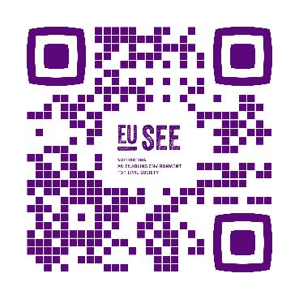

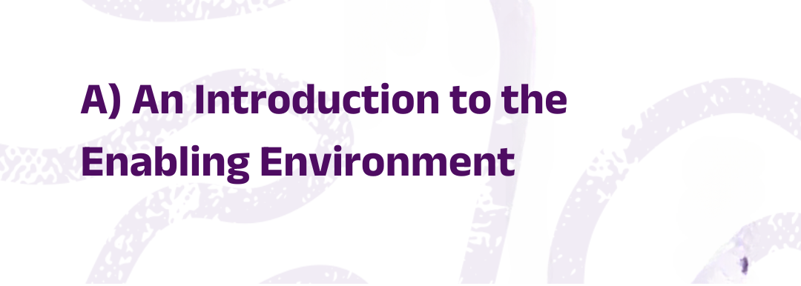
What we understand by an Enabling Environment is the combination of laws, rules and social attitudes that support and promote the work of civil society. Within such an environment, civil society can engage in political and public life without fear of reprisals, openly express its views, and actively participate in shaping its context. This includes a supportive legal and regulatory framework for civil society, ensuring access to information and resources that are sustainable and flexible to pursue their goals unhindered, in safe physical and digital spaces. In an enabling environment, the state demonstrates openness and responsiveness in governance, promoting transparency, accountability, and inclusive decision-making. Positive values, norms, attitudes, and practices towards civil society from state and non-state actors further underscore the supportive environment.

To capture the state of the Enabling Environment, we use the following six principles:
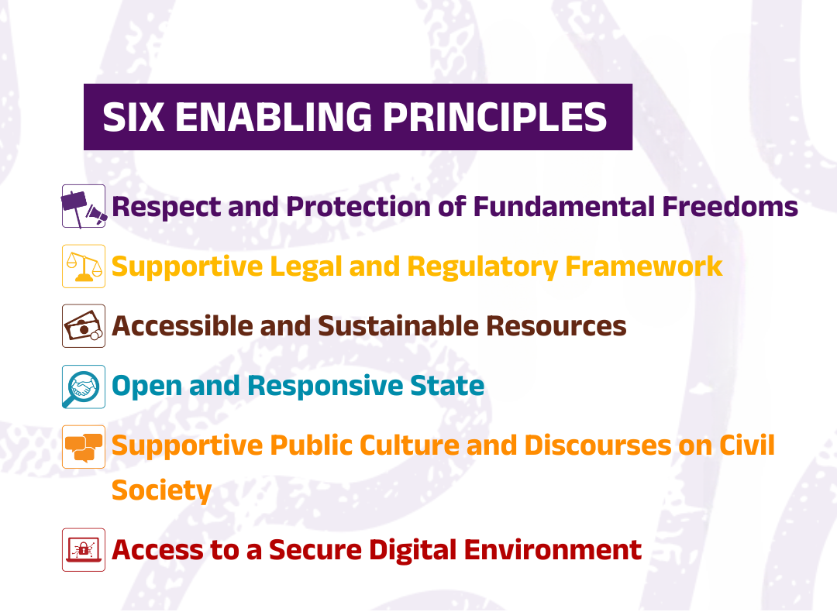

In this Country Focus Report, each enabling principle is assessed with a quantitative score and complemented by an analysis and recommendations written by our Network Members. Rather than offering a singular index to rank countries, the report aims to measure the enabling environment for civil society across the 6 principles, discerning dimensions of strength and those requiring attention.
The findings presented in this report are grounded in the insights and diverse perspectives of civil society actors who came together in a dedicated panel with representatives from civil society to discuss and evaluate the state of the Enabling Environment. Their collective input enriches the report with a grounded, participatory assessment. This primary input is further supported by secondary sources of information, which provide additional context and strengthen the analysis.

Brief Overview of the Country Context
SECTION FOR OPTIONAL QUOTE FROM NM? "Lorem ipsum dolor sit amet, consectetur adipiscing elit, sed do eiusmod tempor incididunt ut labore et dolore magna aliqua. Ut enim ad minim veniam.
"Lorem ipsum dolor sit amet, consectetur adipiscing elit, sed do eiusmod tempor incididunt ut labore et dolore magna aliqua. Ut enim ad minim veniam, quis nostrud exercitation ullamco laboris nisi ut aliquip ex ea commodo consequat. Duis aute irure dolor in reprehenderit in voluptate velit esse cillum dolore eu fugiat nulla pariatur. Excepteur sint occaecat cupidatat non proident, sunt in culpa qui officia deserunt mollit anim id est”

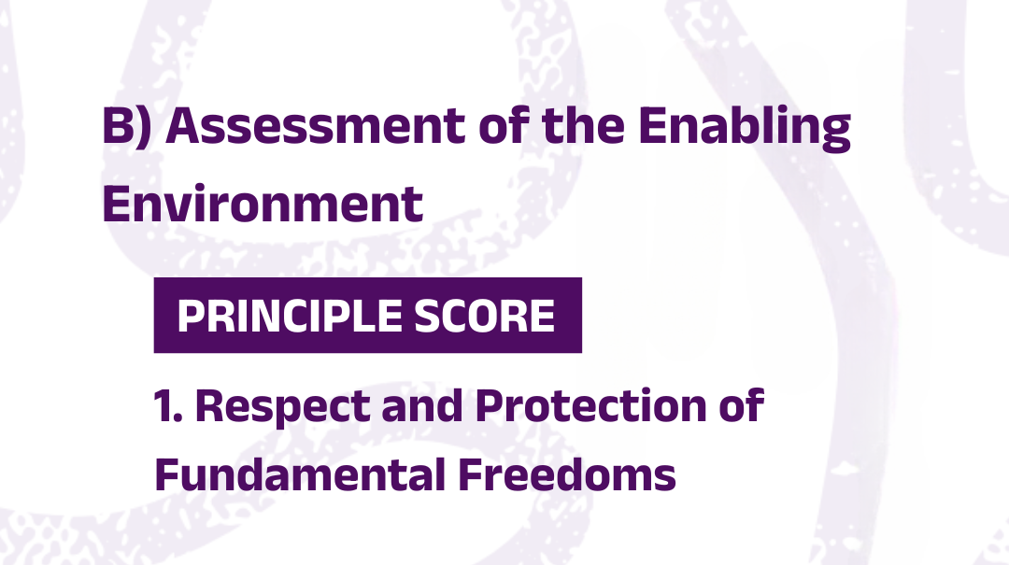
Score: x/5 ()

Infographic Space, Keep Blank

SECTION FOR OPTIONAL QUOTE FROM NM "Lorem ipsum dolor sit amet, consectetur adipiscing elit, sed do eiusmod tempor incididunt ut labore et dolore magna aliqua. Ut enim ad minim veniam.
"Lorem ipsum dolor sit amet, consectetur adipiscing elit, sed do eiusmod tempor incididunt ut labore et dolore magna aliqua. Ut enim ad minim veniam, quis nostrud exercitation ullamco laboris nisi ut aliquip ex ea commodo consequat. Duis aute irure dolor in reprehenderit in voluptate velit esse cillum dolore eu fugiat nulla pariatur. Excepteur sint occaecat cupidatat non proident, sunt in culpa qui officia deserunt mollit anim id est”

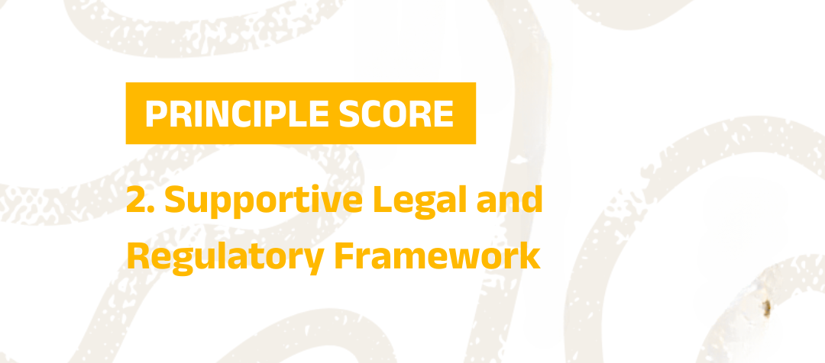
Score: x/5

Infographic Space, Keep Blank

SECTION FOR OPTIONAL QUOTE FROM NM "Lorem ipsum dolor sit amet, consectetur adipiscing elit, sed do eiusmod tempor incididunt ut labore et dolore magna aliqua. Ut enim ad minim veniam.

"Lorem ipsum dolor sit amet, consectetur adipiscing elit, sed do eiusmod tempor incididunt ut labore et dolore magna aliqua. Ut enim ad minim veniam, quis nostrud exercitation ullamco laboris nisi ut aliquip ex ea commodo consequat. Duis aute irure dolor in reprehenderit in voluptate velit esse cillum dolore eu fugiat nulla pariatur. Excepteur sint occaecat cupidatat non proident, sunt in culpa qui officia deserunt mollit anim id est”

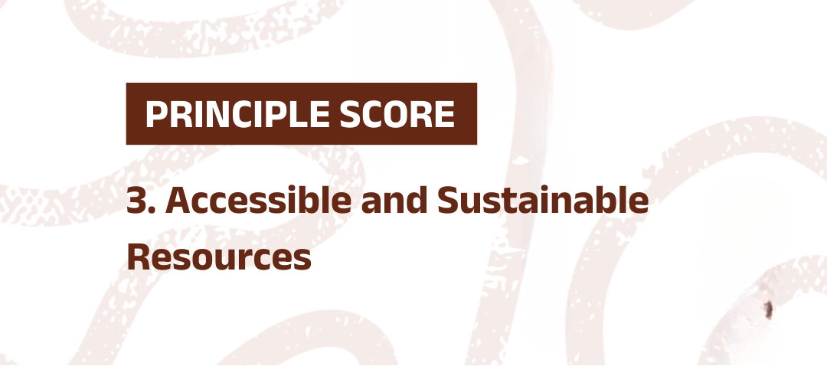
Score: x/5

Infographic Space, Keep Blank

SECTION FOR OPTIONAL QUOTE FROM NM "Lorem ipsum dolor sit amet, consectetur adipiscing elit, sed do eiusmod tempor incididunt ut labore et dolore magna aliqua. Ut enim ad minim veniam.

"Lorem ipsum dolor sit amet, consectetur adipiscing elit, sed do eiusmod tempor incididunt ut labore et dolore magna aliqua. Ut enim ad minim veniam, quis nostrud exercitation ullamco laboris nisi ut aliquip ex ea commodo consequat. Duis aute irure dolor in reprehenderit in voluptate velit esse cillum dolore eu fugiat nulla pariatur. Excepteur sint occaecat cupidatat non proident, sunt in culpa qui officia deserunt mollit anim id est”.

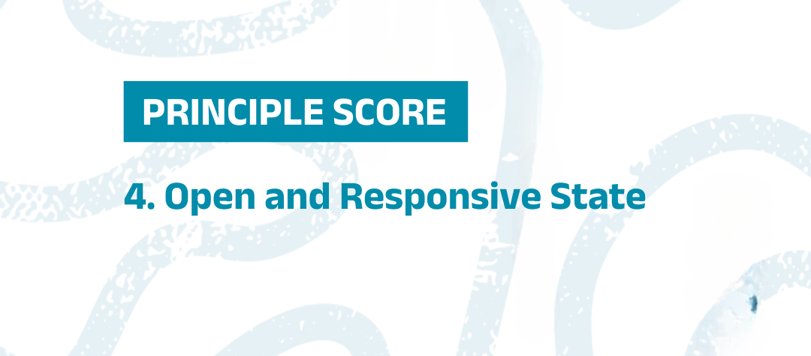

Score: x/5

Infographic Space, Keep Blank

SECTION FOR OPTIONAL QUOTE FROM NM "Lorem ipsum dolor sit amet, consectetur adipiscing elit, sed do eiusmod tempor incididunt ut labore et dolore magna aliqua. Ut enim ad minim veniam.
"Lorem ipsum dolor sit amet, consectetur adipiscing elit, sed do eiusmod tempor incididunt ut labore et dolore magna aliqua. Ut enim ad minim veniam, quis nostrud exercitation ullamco laboris nisi ut aliquip ex ea commodo consequat. Duis aute irure dolor in reprehenderit in voluptate velit esse cillum dolore eu fugiat nulla pariatur. Excepteur sint occaecat cupidatat non proident, sunt in culpa qui officia deserunt mollit anim id est”

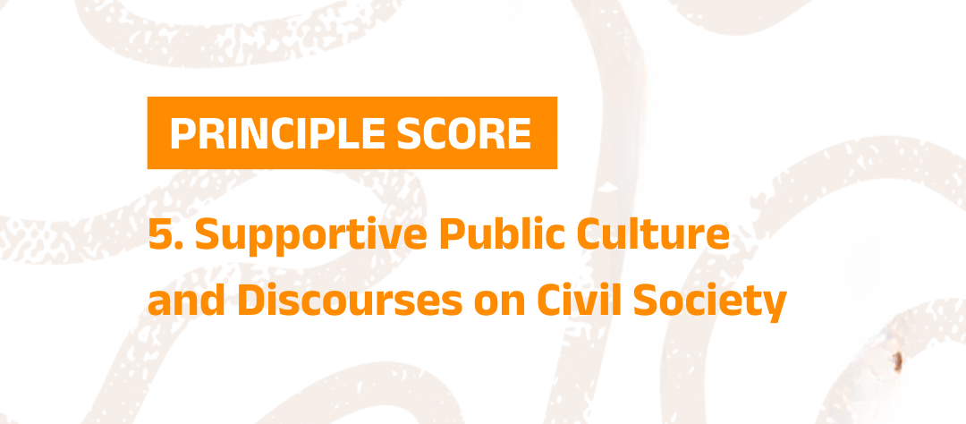
Score: x/5

Infographic Space, Keep Blank

SECTION FOR OPTIONAL QUOTE FROM NM "Lorem ipsum dolor sit amet, consectetur adipiscing elit, sed do eiusmod tempor incididunt ut labore et dolore magna aliqua. Ut enim ad minim veniam.

Lorem ipsum dolor sit amet, consectetur adipiscing elit, sed do eiusmod tempor incididunt ut labore et dolore magna aliqua. Ut enim ad minim veniam, quis nostrud exercitation ullamco laboris nisi ut aliquip ex ea commodo consequat. Duis aute irure dolor in reprehenderit in voluptate velit esse cillum dolore eu fugiat nulla pariatur. Excepteur sint occaecat cupidatat non proident, sunt in culpa qui officia deserunt mollit anim id est”

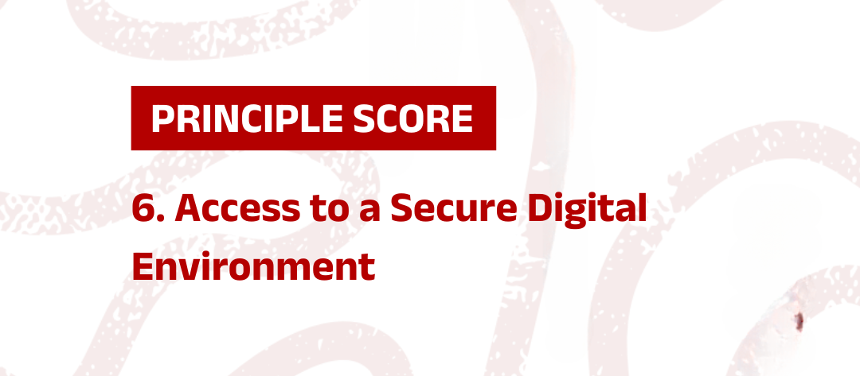

Score: x/5

Infographic Space, Keep Blank

SECTION FOR OPTIONAL QUOTE FROM NM "Lorem ipsum dolor sit amet, consectetur adipiscing elit, sed do eiusmod tempor incididunt ut labore et dolore magna aliqua. Ut enim ad minim veniam.
"Lorem ipsum dolor sit amet, consectetur adipiscing elit, sed do eiusmod tempor incididunt ut labore et dolore magna aliqua. Ut enim ad minim veniam, quis nostrud exercitation ullamco laboris nisi ut aliquip ex ea commodo consequat. Duis aute irure dolor in reprehenderit in voluptate velit esse cillum dolore eu fugiat nulla pariatur. Excepteur sint occaecat cupidatat non proident, sunt in culpa qui officia deserunt mollit anim id est”.

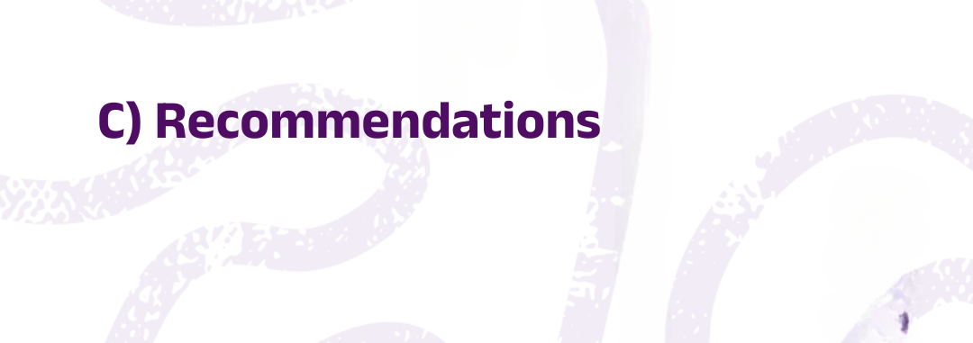

SECTION FOR OPTIONAL QUOTE FROM NM "Lorem ipsum dolor sit amet, consectetur adipiscing elit, sed do eiusmod tempor incididunt ut labore et dolore magna aliqua. Ut enim ad minim veniam.

- "Lorem ipsum dolor sit amet, consectetur adipiscing elit, sed do eiusmod tempor incididunt ut labore et dolore magna aliqua. Ut enim ad minim veniam, quis nostrud exercitation ullamco laboris nisi ut aliquip ex ea commodo consequat. Duis aute irure dolor in reprehenderit in voluptate velit esse cillum dolore eu fugiat nulla pariatur. Excepteur sint occaecat cupidatat non proident, sunt in culpa qui officia deserunt mollit anim id est”

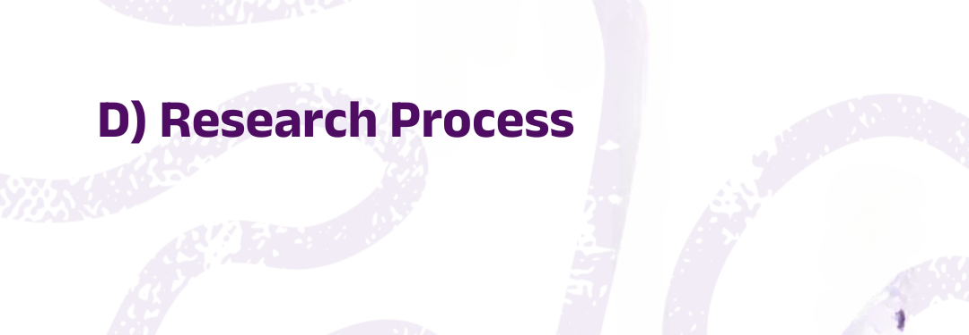

Each principle encompasses various dimensions which are assessed and aggregated to provide quantitative scores per principle. These scores reflect the degree to which the environment within the country enables or disables the work of civil society. Scores are on a five-category scale defined as: fully disabling (1), disabling (2), partially enabling (3), enabling (4), and fully enabling (5). To complement the scores, this report provides a narrative analysis of the enabling or disabling environment for civil society, identifying strengths and weaknesses as well as offering recommendations. The process of drafting the analysis is led by Network Members; the consortium provides quality control and editorial oversight before publication.

For Principle 1 - which evaluates respect for and protection of freedom of association and peaceful assembly - the score integrates data from the CIVICUS Monitor. However, for Principles 2–6, the availability of yearly updated external quantitative indicators for the 86 countries part of the EUSEE programme are either limited or non-existent. To address this, Network Members convene a panel of representatives of civil society and experts once a year. This panel uses a set of guiding questions to assess the status of each principle and its dimensions within the country. The panel for this report was convened in <month>. The discussions are supported by secondary sources, such as V-Dem, the Bertelsmann Stiftung Governance Index, the RTI Rating from the Centre for Law and Democracy, and other trusted resources. These sources provide benchmarks for measuring similar dimensions and are complemented by primary data collection and other secondary sources of information available for the country. Guided by these deliberations, the panel assigns scores for each dimension, which the Network Members submit to the Consortium, accompanied by detailed justifications that reflect the country’s specific context. To determine a single score per principle, the scores assigned to each dimension are aggregated using a weighted average, reflecting the relative importance of each dimension within the principle. This approach balances diverse perspectives while maintaining a structured and objective evaluation framework.

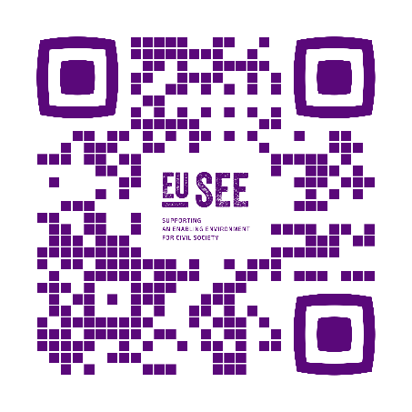
This publication was funded by the European Union. Its contents are the sole responsibility of the author and do not necessarily reflect the views of the European Union.



This is a rebased score derived from the CIVICUS Monitor rating published in December 2025.

